**Practical: 2**

**Aim: Implement common bus system of four 4-bit register using 4x1**

**multiplexer.**

**Theory:**

Way of constructing a common bus system is with multiplexers. The multiplexers select the source register whose binary information is then placed on the bus. The construction of a bus system for four registers is shown in Figure. Each register has four bits, numbered 0 through 3. The bus consists of four 4x1 multiplexers each having four data inputs, 0 through 3, and two selection inputs, S1 and S0 . In order not to complicate the diagram with 16 lines crossing each other, we use labels to show the connections from the outputs of the registers to the inputs of the multiplexers. For example, output 1 of register A is connected to input 0 of MUX 1 because this input is labeled A1 .The diagram shows that the bits in the same significant position in each register are connected to the data inputs of one multiplexer to form one line of the bus. Thus MUX 0 multiplexes the four 0 bits of the registers, MUX 1 multiplexes the four 1 bits of the registers, and similarly for the other two bits.

The two selection lines S1 and S0 are connected to the selection inputs of all four multiplexers. The selection lines choose the four bits of one register and transfer them into the four-line common bus. When S1S0 = 00, the 0 data inputs of all four multiplexers are selected and applied to the outputs that form the bus. This causes the bus lines to receive the content of register A since the outputs of this register are connected to the 0 data inputs of the multiplexers. Similarly, register B is selected if S1S0 = 01, and so on. Below table shows the register that is selected by the bus for each of the four possible binary values of the selection lines.

|  |  |  |
| --- | --- | --- |
| S1 | S0 | Register selected |
| 0 | 0 | A |
| 0 | 1 | B |
| 1 | 0 | C |
| 1 | 1 | D |

In general, a bus system will multiplex k registers of n bits each to produce an n-line common bus. The number of multiplexers needed to construct the bus is equal to n, the number of bits in each register. The size of each multiplexer must be k x 1 since it multiplexes k data lines. For example, a common bus for eight registers of 16 bits each requires 16 multiplexers, one for each line in the bus. Each multiplexer must have eight data input lines and three selection lines to multiplex one significant bit in the eight registers.

**Circuit:**

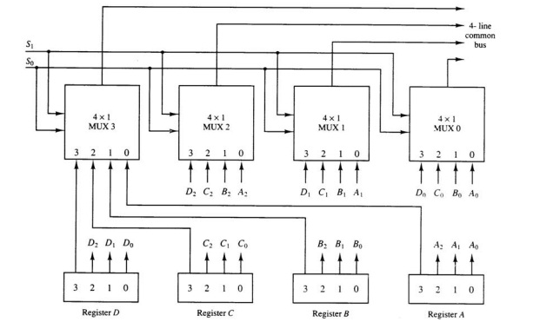

**Practical Circuit:**

